**HVAC Proposal App**

AUTHOR:

Jacob Dominski

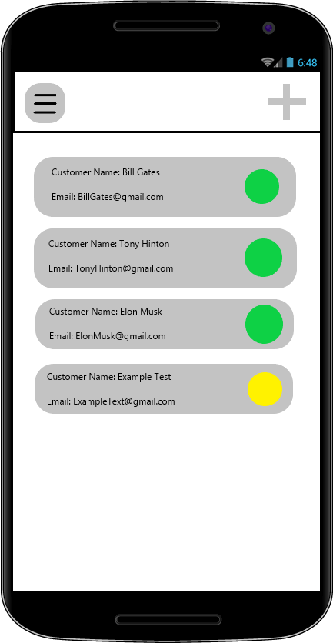

**Technical Field**

My project involves the technical fields of Software Engineering and Computer Science.

**Background Information**

The inspiration for my project stems from noticing a lack of technological use in the field of HVAC. Within my client’s company, they currently have to use pen and paper to write a proposal for their customers. This process can take upwards to one day and during that time, they have the potential to lose that customer to a competitor. I would like to make an app that shorten the process to only take a couple of minutes.

**Prior Art**

**Go Canvas:** A mobile application that creates and automates proposal forms. An idea similar to mine but lacks user-friendly features and decent core functionality.

[**https://www.gocanvas.com/mobile-forms-apps/137-Heating-Ventilation-Air-Conditioning-HVAC-/show_category (Links to an external site.)**](https://www.gocanvas.com/mobile-forms-apps/137-Heating-Ventilation-Air-Conditioning-HVAC-/show_category)

**Utility Mobile Apps:** Another proposal builder that is not user-friendly. I could not find any way to demo the application.

[**https://www.utilitymobileapps.com/hvac-estimates-app/ (Links to an external site.)**](https://www.utilitymobileapps.com/hvac-estimates-app/)

**Proposal Builder:** An out-of-date proposal builder that is only compatible with iPad 3rd and 4th generation. It does not include the expected features from my client’s list of requirements.

[**https://download.cnet.com/HVAC-Proposal-Builder-Pro/3000-2124_4-76366991.html (Links to an external site.)**](https://download.cnet.com/HVAC-Proposal-Builder-Pro/3000-2124_4-76366991.html)

**Project Description**

This project aims to create a faster and more efficient workflow within my client’s company. My application will be catered towards the HVAC industry where a big portion of that industry still use pen and paper. Additionally, the application will be supported on both iOS and Android although it will have better optimization for iOS because that is the operating system my client uses. My idea would let the technician create the proposal while on the job to decreasing the time taken to get the customer to agree to the proposal. This would increase workflow and efficiency by approximately 25% – 30%. The app works by letting the technician create a form where they select the options the customer needs for an AC unit installation. Then, it will generate a form where both the customer and the technician will sign the document and an email will be sent to both the company and the customer so work can begin.

**Innovation Claim**

My application aims to create a faster and more efficient workflow for the HVAC industry, helping to change the way my clients conduct business and engage with their customers in a new and technological way

**Usage Scenario**

The main purpose of my product is to increase customer satisfaction by providing a software that automates time consuming tasks. That task being proposal creation. A technician may use this software in the field and on site to where the AC Inspection is taken place.

**Evaluation Criteria**

Start this section with a statement like: “The following questions will identify the successful completion of the project.” Then, in the form of **“Yes/No”** questions, list the criteria you/your team will use to determine the success/completion of your project in terms of usability or usefulness of the product you will eventually prototype. Provide as many criteria as required to assure the quality of the project; each one needs to be expressed in such a way that it is measurable or observable, and should be in the form of a **yes or no** question. Also, do NOT answer the questions. This is simply a list of what the criteria are.

The following questions will identify the successful completion of the project.

1. Does the app include an interactive experience and have all of the necessary options available for the user to select?
2. Do all aspects of the application perform to a superior standard?
3. Are the UX and UI designs enjoyable, simple, and easy to use for the user?
4. Is the content in the application void of any grammatical, typographical, or syntax errors while displaying accurate information?
5. Does the final proposal document meet the standards of the client and portray accurate information for both the company and the customer?

**Objectives and Tasks Associated with the Project**

Objective 1 - Core Functionality. Completion date: February 14th, 2021

          Activity a - Build the Framework UI that the user can navigate and see different screens.

          Activity b - Make it User Friendly

          Activity c - Add the settings window

          Activity d - Add functionality to generate a basic proposal

          Activity e - Include basic options the user can select

Objective 2 - Add a PDF Viewer Component. Completion date: February 28th, 2021

          Activity a - Implement a PDF viewer component

          Activity b - Add the component after the user has selected the options for the proposal

          Activity c - Add a required tag to some of the options that prevents the user from moving to the PDF Viewer

          Activity d - Add a back button in case the user chose incorrect options

          Activity e - Include legal text in the proposal and format the text based on the options the user chose

          Activity f - Implement a complete button that finalizes the component

Objective 3 - Implement a local save feature (Final version will store data in a database). Completion date: March 28th, 2021

          Activity a - all previous finalized proposals will be saved locally for the prototype. For the final version, they will be stored in a database and the mobile app will pull data from it and display it to the user

          Activity b - add a search bar at the top to look for proposals

          Activity c - add a default sort option in the settings by either data oldest or newest or alphabetical                  (forward or reverse for both first name and last name).

          Activity d - The UI will be displayed as a card where it will show the customer's name, email address,                 and the technician who filled out the proposal

Objective 4 - Create a Database to store company proposals (Final version only). Completion date: May 16th, 2021

          Activity a - Set up database using Google Firebase

          Activity b - Implement a login and registration form for the application

          Activity c - Companies will register with the company email and employees will register and include                  their company's email.

          Activity d - store data (most likely in a json format) in the data base that the mobile app can pull from

          Activity e - implement a backend script to send emails to customers and the company

***Note: This section must be revised prior to SIP401 to describe tasks as they actually occurred.***

**Description of Design Prototype**

The prototype for my application will be a rudimentary mobile app that will let you fill out forms and generate pdfs. What holds my prototype back from a completed product will be its lack of usability in the field. The final version will have a database that the app can connect to and save data on. In terms of which platform I will be using, I will be using the React Native Framework and will be optimizing my application for iOS.

***Note: This section will be revised prior to SIP401 to describe the design prototype in its final form.***

**Evaluation Plan**

My project has a great deal of components and features that need to be implemented for it to succeed. One of these requirements is to have an interactive and enjoyable experience for the user by including all the necessary options for the user. This can be easily implemented just by communicating with the client on what they want to see with the application. Additionally, another requirement is having the application perform to a superior standard which can only be judged by the client. The last requirement that’s important is the final product using my application (The actual proposal). That needs to be accurate and formatted nicely so that their customers can understand my client’s plan for whatever service they’re providing.

***Note: This section must be revised prior to SIP401 to describe the full evaluation plan as it was actually implemented.***

**Project Completion Assessment**

***Note: This section must completed prior to SIP401***

Provide an in-depth description of the completion assessment of your project. Describe how well the completed components function and highlight the innovative facets of your design. This is sometimes known as a “Post-Mortem” or “Lessons-Learned Report”. A good approach for this section is to answer the following 4 questions: “What went right? What went wrong? What was learned throughout the process? What would be done differently if you had to do it again?

Throughout this semester, the process of figuring out a SIP went smoothly. I started off with two ideas and went with the one that got accepted. Everything seemed to fit into place with the project and formulating the steps to complete it. Currently, I have a small demo running on an emulator that’s basically a prototype of a prototype. For me, the only thing that went wrong was spending too much time on other assignments that were non-essential which gave me limited time to focus on my SIP. Throughout the process, I learned a lot through research and actually doing the project. If I had to go through this again, I would probably spend more time on the prototype to get it to a better state than what it is currently.

**Appendices**

***Note: This section must completed prior to SIP401.***

Appendix A: rendered images of the user interface –

 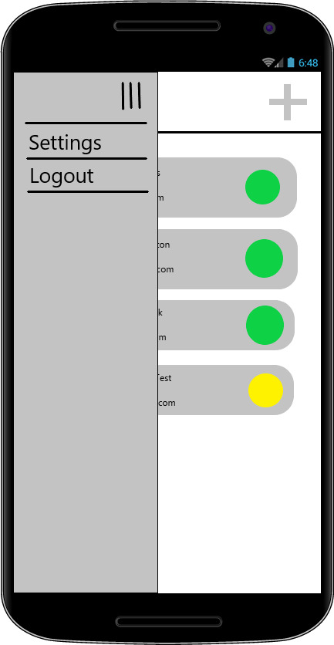 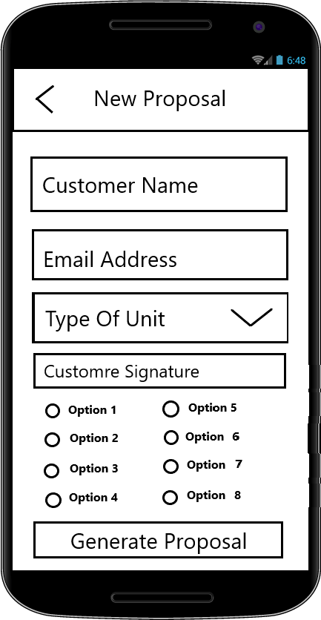 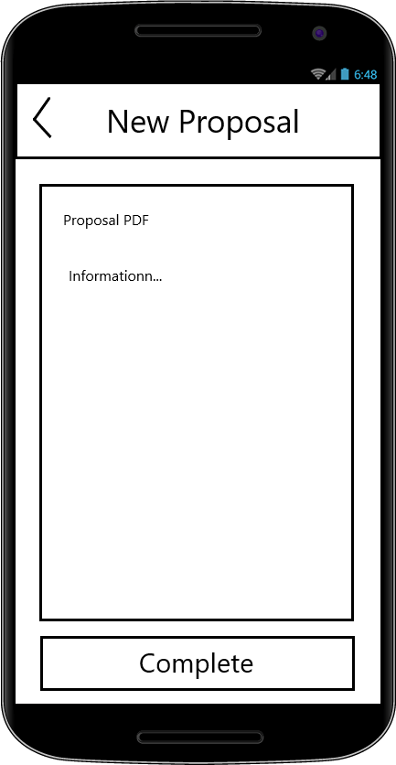

Appendix B: Working Prototype

